SAC Report :
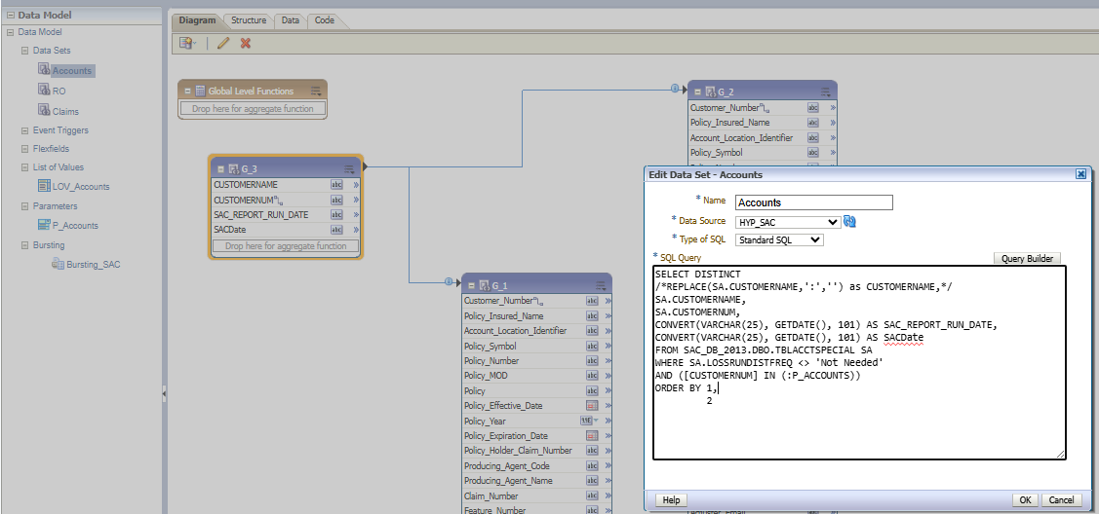

HYP_SAC: jdbc:hyperion:sqlserver://Homsql10dc\dc:1433;DatabaseName=SAC_DB_2013

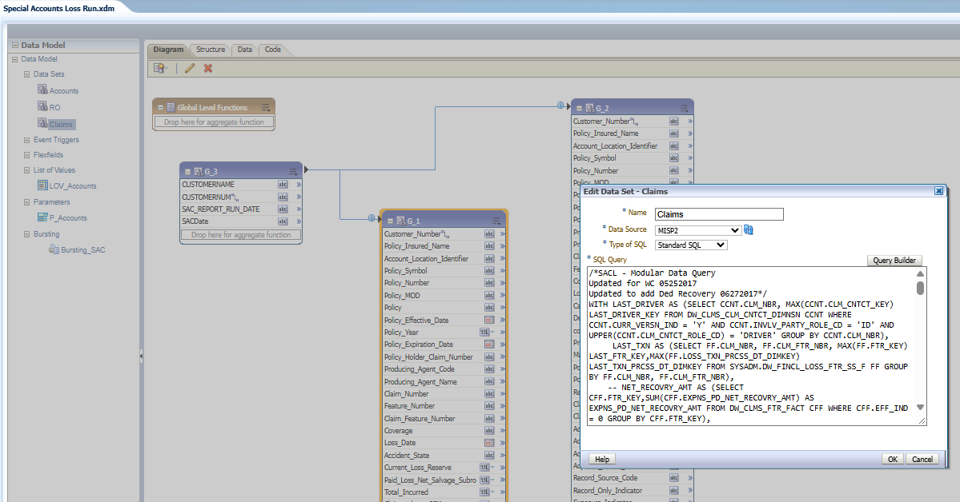

MISP2: jdbc:oracle:thin:@prfinexa.hanover.com:1521/MISP2_S
